**ELEN 4720: Machine Learning for Signals, Information and Data**

Homework #3

Rakshith Kamath (rk3165)

November 21, 2021

**Problem-1 (Boosting Coding)**

1. The upper bound and the training error is plotted as shown after 2500 iterations of the AdaBoosting algorithm.

1. The stem plotfor 999 weights is shown below-

1. The Plots for alpha and epsilon are shown below respectively-

**Problem-2-(K-Means)**

1. We have shown how objective function varies for various values of K for 20 iterations-

1. The cluster assignment for K=3 and K=5 is shown respectively in the below figures-

**Problem-3(Bayes Classifier Revisited)**

1. The log marginal objective function for class 0 and class 1 are shown below respectively for 10 different runs which are 30 iterations each.

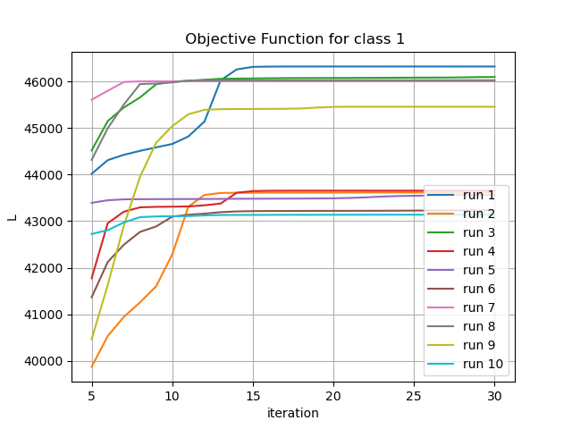

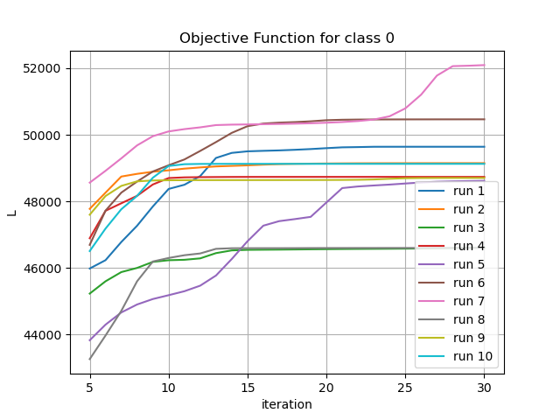

1. Confusion matrix and their accuracy for K=1,2,3,4 is shown respectively-

|  |  |  |  |
| --- | --- | --- | --- |
| K=1 | Predict | | |
| Actual |  | y_pred=0 | y_pred=1 |
| y=0 | 180 | 98 |
| y=1 | 6 | 175 |
| Accuracy=77% | | | |

Table 1-Bayes classifier for K=1

|  |  |  |  |
| --- | --- | --- | --- |
| K=2 | Predict | | |
| Actual |  | y_pred=0 | y_pred=1 |
| y=0 | 195 | 83 |
| y=1 | 9 | 172 |
| Accuracy=80% | | | |

Table 2-Bayes classifier for K=2

|  |  |  |  |
| --- | --- | --- | --- |
| K=3 | Predict | | |
| Actual |  | y_pred=0 | y_pred=1 |
| y=0 | 202 | 76 |
| y=1 | 8 | 173 |
| Accuracy=82% | | | |

Table 3-Bayes classifier for K=3

|  |  |  |  |
| --- | --- | --- | --- |
| K=4 | Predict | | |
| Actual |  | y_pred=0 | y_pred=1 |
| y=0 | 234 | 44 |
| y=1 | 13 | 168 |
| Accuracy=88% | | | |

Table 4-Bayes classifier for K=4